Ethan Allen Triple Door Cupboard

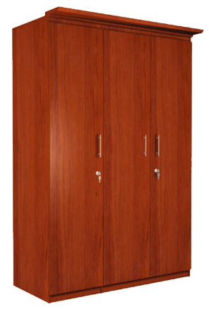

|  |
| --- |
| **DESCRIPTION** |
| Ethan Allen interior designing has introduced an extra long multi storage cupboard with wide triple storage space. The cupboard has a nice feel with smooth surface and the brown color enables it to give a natural look. The underground secret storage system helps you to hide your valuables which has compartment hidden by three layers makes it very difficult to locate the valuables. |

|  |  |  |
| --- | --- | --- |
| **Price** | **570$** | |
| **Dimensions** | **H** x **W** x **L** | **75in x 28in x 36in** |
| **Features** | **The security protection level of this cupboard is very high perfect for hiding valuables and location of compartment is only known to the owner** | |
| **Finished** | **Smooth polished granite inducement** | |
| **Available in** | **Brownish Red Only** | |